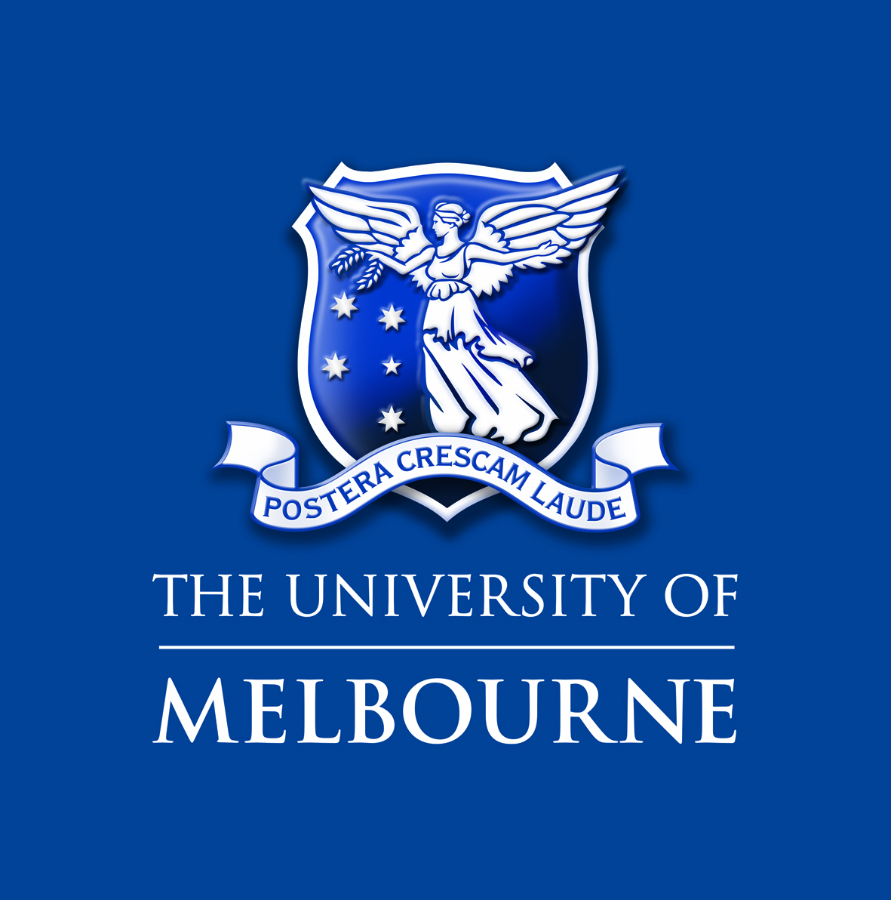

School of Geography

Two PhD projects in youth in India (commencing January 2021 or negotiable).

Thesis topic: Understanding the social action of young people in north India (fieldsite in Uttar Pradesh or Uttarakhand) with particular reference to how they are engaged in social change, for example in relation to ideas of equality, freedom, and development.

Project description: Young people in India are playing key roles in shaping society. This is occurring in fields as diverse as agriculture, economic development, health, education, and cultural practice. This project focuses on young people’s active and creative efforts to reshape different areas of Indian society, with a particular focus on their engagement with ideas of freedom, equality, and development. The project will involve intensive fieldwork among young people in north India, including interviews and participant observation. The project will contribute to scholarly, policy and public understanding of young people’s social action in India.
Supervisors: Dr. Jane Dyson (School of Geography, the University of Melbourne), and Professor Craig Jeffrey (School of Geography and Australia India Institute)
Skills required: experience of social science methods (especially interviews and participant observation), preferably experience of South Asian society and scholarly debates, interest in youth studies, ability in Hindi or capacity and willingness to learn Hindi.

We would encourage students with excellent skills and a relevant Masters/Honours degree in one or more of the following areas to apply: human geography, anthropology, South Asian studies, youth studies, development studies.

Support: Applicants will apply for a scholarship through the Science Faculty of the University of Melbourne. The scholarship will be co-funded through a Melbourne graduate research scholarship and an Australian Research Council Discovery Project (held by Dyson and Jeffrey). In addition to a scholarship and fees remission, graduate researchers will receive a lap-top computer, funding to attend conferences and fieldwork costs.
Research Environment: The University of Melbourne’s School of Geography (recently ranked Level 5 in Research) has a vibrant research culture and an energetic graduate community (www.geography.unimelb.edu.au ). Successful applications will join a growing cohort of graduate researchers conducting social research in India. The School has significant capacity for training graduate researchers and particular expertise in the Indo-Pacific. The University of Melbourne is dedicated to supporting research and building capacity in the Asia-Pacific.
Deadline: Expressions of interest, with full CV, transcripts, and a writing sample are due by 30th July, 2020.

For any information about this research project, contact Craig Jeffrey (craig.jeffrey@unimelb.edu.au) or Jane Dyson (jane.dyson@unimelb.edu.au).

